Essential Source Control with Git SOP



Table of Contents

1. Essential Source Control with Git 3
1.1 Description 3
1.2 Architecture Diagram 3
1.3 Lab Steps 4
1.4 Troubleshooting 5
1.5 Supporting References 5

Essential Source Control with Git

Description
Source control is the practice of tracking and managing changes to code. This ensures that developers are always working on the right version of source code. Generally projects have few branches like Dev, Prod etc. Changes in one branch are merged with final master branch once all the changes are accepted and ready to production.

Architecture Diagram
The diagram below displays a visual representation of the application architecture:
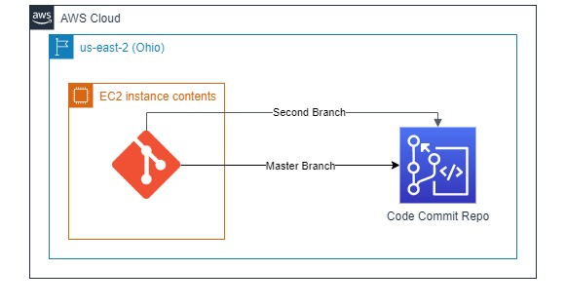

Lab Steps
Follow the steps outlined below to achieve the objective of this lab exercise:

- Create a CodeCommit Repository.
- Create an EC2 Instance (Amazon Linux 2) and SSH into it using the Sessions Manager Option. Note: Make sure CCL-EC2-Role is attached to the instance, only then SSH is possible with Sessions Manager Option.
- Use the command to install git:

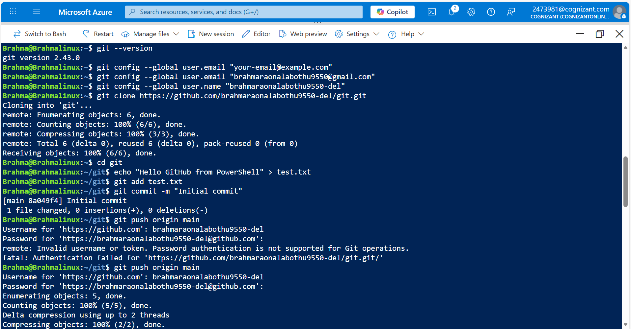
sudo su
sudo yum install git -y
- Configure the system with the user email and user name:
git config --global user.email <some sample mail ID> git config --global user.name <some name>
- Navigate to IAM > Users > Your UserName > Security Credentials > HTTPS Git Credentials for CodeCommit. Here generate credentials and save them.
- Clone the CodeCommit repository using the git clone command which can be found in Step 3 under Connection Steps in created repository.
- Navigate to the repo folder:
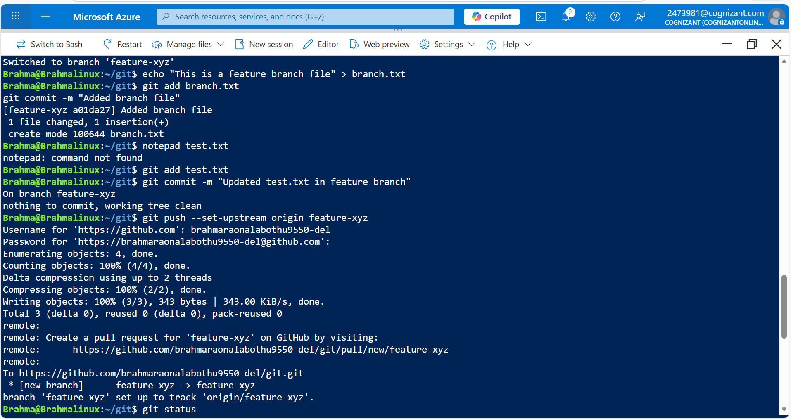
cd <destination path>
- Create some text file with some content in the folder.
- Give the following commands to push the file to the repository:
git add <filename>
git commit –m “Some Commit Message for reference”
git push
Note: The git push command pushes the code by default to Master Branch.
- Verify if the file is reflected in the Code commit Console Page.
- Create a new branch:
git branch <some branch name>
- Switch to the new branch with the following command:
sudo git checkout xyz
- Create a new file and use git command to add the file to stage:
sudo git add <filename>
- From the existing list of files, create change in them and then add it to the branch:
Sudo vim <file_name> sudo git add <file_name>

- Commit your changes using the command:
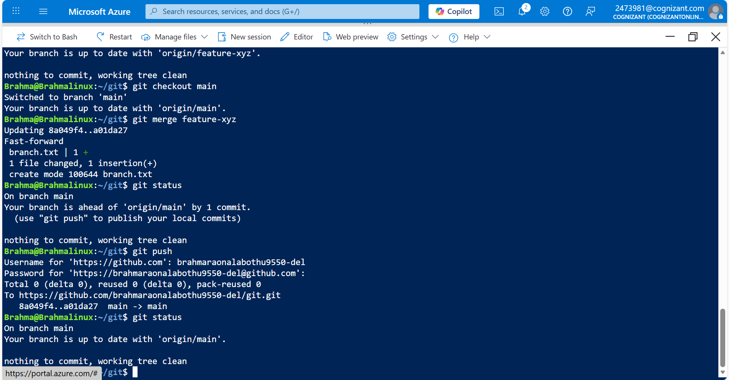
sudo git commit -m “__message__”
- Push the changes into the source repository using the following command:
sudo git push –-set-upstream origin <Branch Name>
Note: A new pull request for the branch is sent to the source repository. Check it in the CodeCommit Console in Branches tab.

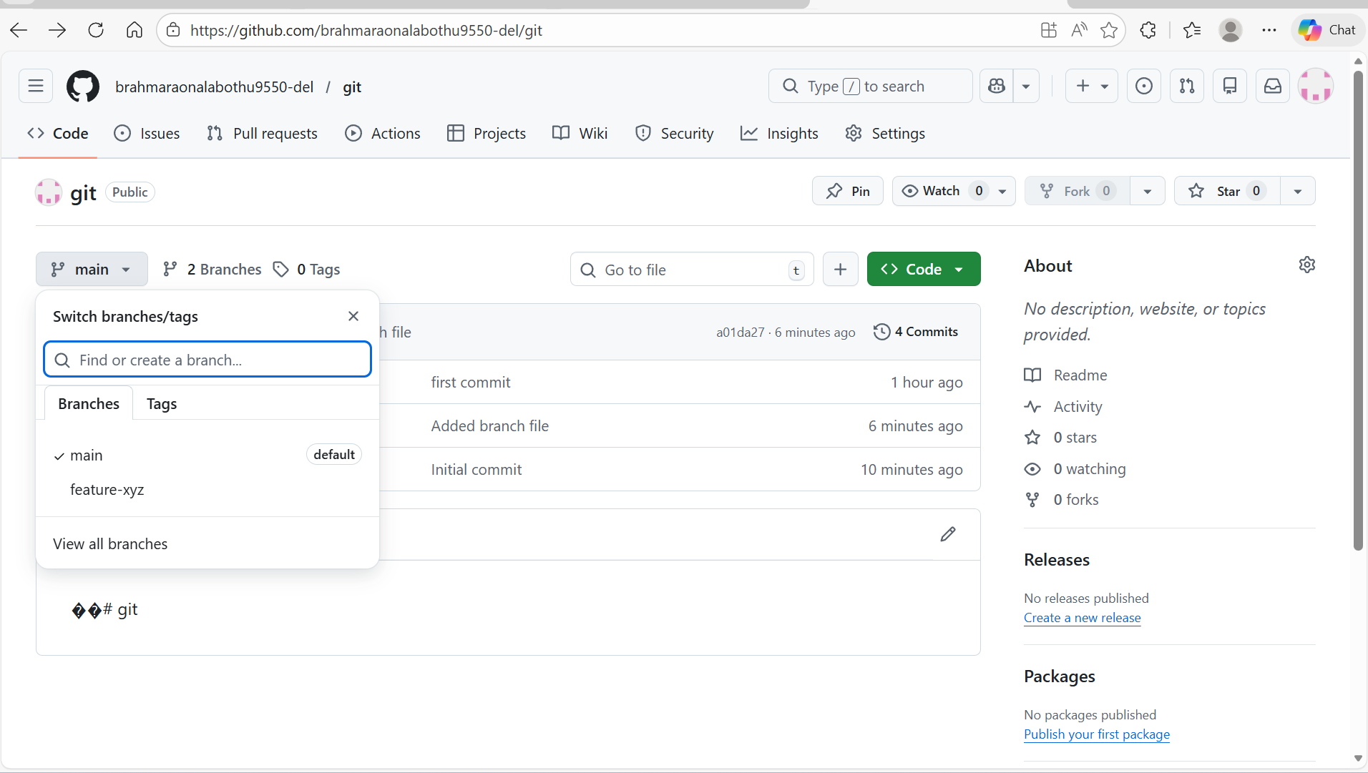

Troubleshooting
S. No | Problem | Solution
1 | Git commands not working | Make sure if Git is installed in your system, if not install it.
2 | Not able to clone repository | Make sure HTTPS Git Credentials are created so that the repository can be cloned.

Supporting References
Refer the below link for additional information:

1. https://docs.aws.amazon.com/codecommit/latest/userguide/how-to-basic-git.html

